The Private Practice Infectious Disease (PPID) Editorial Process
PPID operates a rigorous and transparent peer review process that aims to maximize quality; it is handled by researchers and scholars.

We believe that peer review should be efficient, rigorous, and fair for everyone involved.

Peer review is a single-blind assessment with at least two independent reviewers, followed by a final acceptance/rejection decision by the Editor-in-Chief or another editor approved by the Editor-in-Chief. The Editor-in-Chief is responsible for the academic quality of the publication process, including acceptance decisions; the approval of external editors and topics for article collections, such as Special Issues, Topics, and Topical Collections; and appointing new Editorial Board members.

A summary of the editorial process is given in the flowchart below.

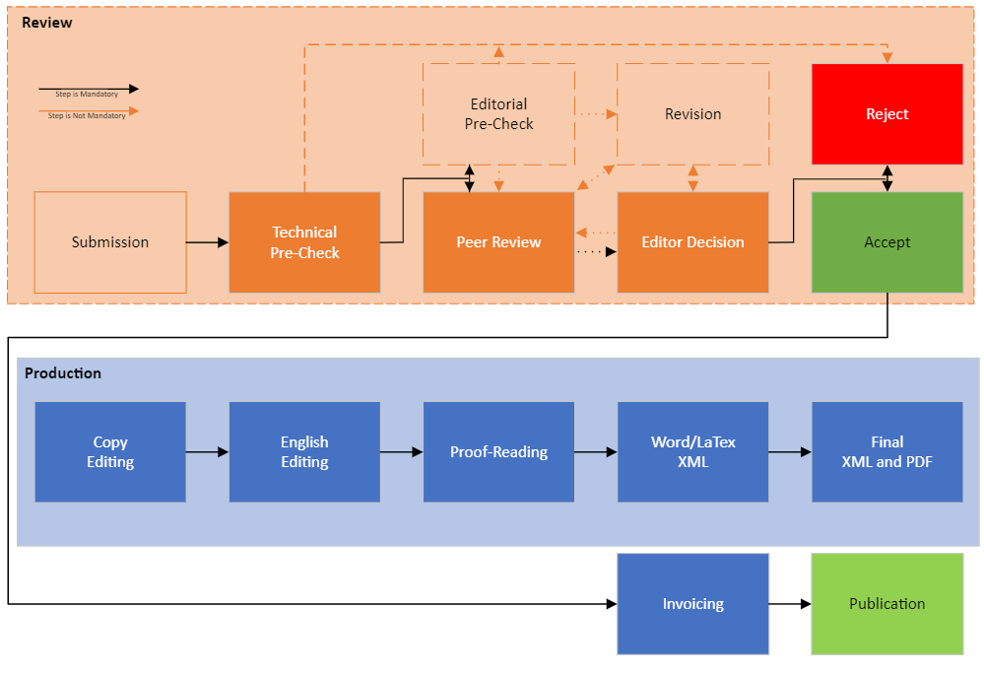

The following provides notes on each step.

Pre-check
The pre-screening stage consists of two main steps: a technical pre-check performed by the Editorial Office and an editorial pre-check performed by an academic editor.

Immediately after submission, the journal’s Managing Editor will perform the technical pre-check to assess:

- The overall suitability of the manuscript to the journal;
- Manuscript adherence to high-quality research and ethical standards;
- Standards of rigor to qualify for further review.
The academic editor (i.e., the Editor-in-Chief in the case of regular submissions, and an Editorial Board member in the case of a conflict of interest and regular submissions if the Editor-in-Chief allows) will be notified of the submission and invited to perform an editorial pre-check. During the editorial pre-check phase, the academic editor will assess the suitability of the submission with respect to the scope of the journal, as well as the overall scientific soundness of the manuscript, including the relevance of the references and the correctness of the applied methodology. The academic editors can decide to reject the manuscript, request revisions before peer review, or continue with the peer review process and recommend suitable reviewers.

Guest Editors are not able to make decisions regarding their own manuscripts submitted, as this would constitute a conflict of interest. An Editorial Board member will instead be responsible for decision making. The Guest Editor will be unable to access the review process except in their role as author. Similarly, Editors-in-Chief or other Editorial Board members are not able to access the review process of their manuscript except in their role as author.

Peer Review
From submission to final decision or publication, one dedicated PPID staff member coordinates the review process and serves as the main point of contact for authors, academic editors, and reviewers.

The process is single-blind, meaning that the author does not know the identity of the reviewer, but the reviewer knows the identity of the author.
At least two review reports are collected for each submitted article. The academic editor can suggest reviewers during pre-check. Alternatively, PPID editorial staff will use qualified Editorial Board members, qualified reviewers from our database, or new reviewers identified by web searches for related articles.

Authors can recommend potential reviewers. PPID staff ensure that there are no potential conflicts of interest and will not consider those with competing interests. Authors can also enter the names of potential peer reviewers they wish to exclude from consideration in the peer review of their manuscript, during the initial submission of the manuscript. The Editorial Team will respect these requests as long as they do not interfere with the objective and thorough assessment of the submission.

The following criteria are applied to all reviewers:

- They should hold no conflicts of interest with any of the authors;
- They should hold an MD, PharmD, or be a PhD;
- They should have relevant experience and have a proven publication record in the field of the submitted paper (Scopus or ORCID);
- They should be experienced scholars in the field of the submitted paper;

Reviewers who are accepted to review a manuscript are expected to:

- Have the necessary expertise to judge manuscript quality;
- Provide quality review reports and remain responsive throughout peer review;
- Maintain standards of professionalism and ethics.
Reviewers who accept a review invitation are provided 7–10 days to write their review via our online platform. Extensions can be granted on request.

When reviewing a revised manuscript, reviewers are asked to provide their report within three days. Extensions can also be granted on request.

To assist academic editors, PPID staff handle all communication with reviewers, authors, and the external editor. Academic editors can check the status of manuscripts and the identity of reviewers at any time, and are able to discuss manuscript review at any stage with PPID staff.

Open Peer review
PPID operates an open peer review option by default, meaning that the authors have the option to publish the review reports and author responses with the published paper (often referred to as open reports). Publishing the reviewer reports and author responses together with the article provides greater transparency and trust for readers as they can track and check the peer review process. The Open Peer Review model also encourages reviewers to provide high quality comments as they will be made public if the article is accepted for publication.

To promote open communication further and increase the robustness of the peer review process, we encourage reviewers to sign their reports so that their name appears on the review report (referred to as open identity). By signing the reports, reviewers receive direct credit for their contribution to the peer review process and also shows their commitment towards open science. The default option is for reviewers to remain anonymous. If an article is rejected no details will be published.

Revision
In cases where only minor or major revisions are recommended, PPID staff will request that the author revise the paper before referring to the academic editor. Where conflicting review reports are present, or where there are one or more recommendations for rejection, feedback from the academic editor is sought before a decision about revisions is communicated to the authors. Additional reviewers or further review reports may be requested by the academic editors at this stage.

Revised versions of manuscripts may or may not be sent to reviewers, depending on whether the reviewer requested to see the revised version. By default, reviewers who request major revisions or recommend rejection will be sent the revised manuscript. All reviewers can access the most recent version of the manuscript via JAMS portal.

A maximum of two rounds of major revision per manuscript are normally provided. If more rounds are required according to the reviewers, PPID staff should request a decision from the academic editor.

If the required revision time is estimated to be longer than 2 months, we recommend that authors withdraw their manuscript before resubmitting so as to avoid unnecessary time pressure and to ensure that all manuscripts are sufficiently revised.

Editor Decision
Acceptance decisions on manuscripts can be made by the academic editor after peer review once a minimum of two review reports have been received. Acceptance decisions are made by an academic editor (the Editor-in-Chief or a suitable Editorial Board member).
When making a decision, we expect the academic editor to check the following:
- The suitability of the selected reviewers;
- The adequacy of reviewer comments and author response;
- The overall scientific quality of the paper.
The academic editor can select from the following options: accept in its current form, accept with minor revisions, reject and decline resubmission, reject but encourage resubmission, ask the author for a revision, or ask for an additional reviewer.

The academic editors should alert the Editorial Office to any potential conflicts of interest that may bias, or be perceived to bias, decision making. More details about PPID's conflicts of interest policy for academic editors can be found at Metro Infectious Disease Consultants COI.

Reviewers make recommendations, and the Editors-in-Chief or academic editors are free to disagree with their views. If they do so, they should justify their decision for the benefit of the authors and reviewers.

In some instances, an academic editor supports the acceptance of a manuscript despite a reviewer’s recommendation to reject it. PPID staff will seek a second independent opinion from an Editorial Board member or the Editor-in-Chief before communicating a final decision to the authors.

Articles can only be accepted for publication by an academic editor. PPID staff will then inform the authors. PPID staff never make paper acceptance decisions.

PPID staff or Editorial Board members (including Editors-in-Chief) are not involved in the processing of their own academic work. Their submissions are assigned and revised by at least two independent reviewers. Decisions are made by other Editorial Board members who do not have a conflict of interest with the authors.

Author Appeals
Authors may appeal a rejection by sending an e-mail to the Editorial Office of the journal. The appeal must provide a detailed justification, including point-by-point responses to the reviewers' and/or Editor's comments. Appeals can only be submitted following a “reject and decline resubmission” decision and should be submitted within three months from the decision date. Failure to meet these criteria will result in the appeal not being considered further. The Managing Editor will forward the manuscript and related information (including the identities of the referees) to a designated Editorial Board Member. The academic editor being consulted will be asked to provide an advisory recommendation on the manuscript and may recommend acceptance, further peer review, or uphold the original rejection decision. This decision will then be validated by the Editor-in-Chief. A reject decision at this stage is final and cannot be reversed.

Production
PPID will perform production on all manuscripts, including language editing, copy editing, and conversion to XML. Language editing is carried out by professional English editing staff. In the small number of cases where extensive editing or formatting is required, we offer authors an English editing service for an additional fee (with the authors’ prior approval). The authors are also free to use other English editing services, or consult a native English-speaking colleague—the latter being our preferred option.

Publication Ethics
PPID follows the Committee on Publication Ethics (COPE), including following its Principles of Transparency and Best Practice in Scholarly Publishing. Our journal follows COPE’s procedures for dealing with potentially unethical behavior by authors, reviewers, or editors.

Details on ethical considerations for submitting papers can be found in the instructions for authors.

Ethical issues raised by readers of the journal will be investigated by the editorial office following procedures recommended by COPE. Disputes on the validity of research reported in published papers can be settled by the Editorial Board. For disputes around authorship, data ownership, author misconduct, etc. Authors are asked to respond to any substantiated allegations made against them.

To manage authorship disputes, we follow COPE guidelines, particularly How to spot authorship problems. Typically, if all authors agree, the authorship can be updated via a Correction. If not, we require an authoritative statement from the authors' institution(s) about who qualifies for authorship.

Publishing Standards and Guidelines
PPID follows the following guidelines and standards for its journal:

ICMJE: PPID follows the recommendations of the International Committee of Medical Journal Editors. The guidelines comprehensively cover all aspects of editing, from how the journal is managed to details about peer review and handling complaints.

The CONSORT statement covers the reporting of randomized, controlled trials. We encourage authors to verify their work against the checklist and upload them with their submission.

TOP covers transparency and openness in the reporting of research. Our journals aim to be at level 1 or 2 for all aspects of TOP. Specific requirements vary between journals and can be requested from the editorial office.

FAIR Principles cover guidelines to improve the Findability, Accessibility, Interoperability and Reuse of data.

PRISMA covers systematic reviews and meta-analyses. Authors are recommended to complete the checklist and flow diagram and include it with their submission.

ARRIVE contains guidelines for reporting in vivo experiments. Authors are recommended to verify their work against the checklist and include it with their submission.

iThenticate is an industry-standard software for plagiarism detection. Used during the first screening of a manuscript or pre-check, it can also be used at any stage of the peer review process and especially before the acceptance of a manuscript for publication.

Compliance with the standards and guidelines above will be taken into account during the final decision and any discrepancies should be clearly explained by the authors. We recommend that authors highlight relevant guidelines in their cover letter.

Editorial Independence
All articles published by PPID are peer-reviewed and assessed by our independent Editorial Boards, and PPID staff are not involved in decisions to accept manuscripts. When making a decision, we expect the academic editor to make it based solely upon:

- The suitability of the selected reviewers;
- The adequacy of the reviewer comments and author’s response;
- The overall scientific quality of the paper.
PPID policies are informed by the mission to make science and research findings open and accessible as widely and rapidly as possible.

